Ahmed salah G1
Remote backend dynamo DB table and S3 Bucket
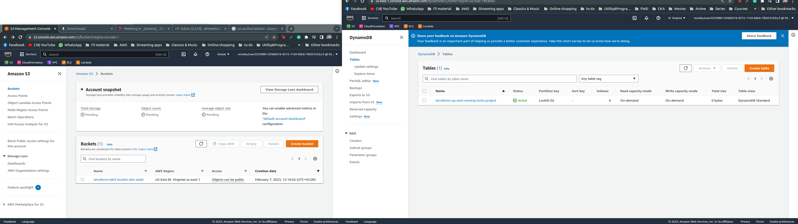

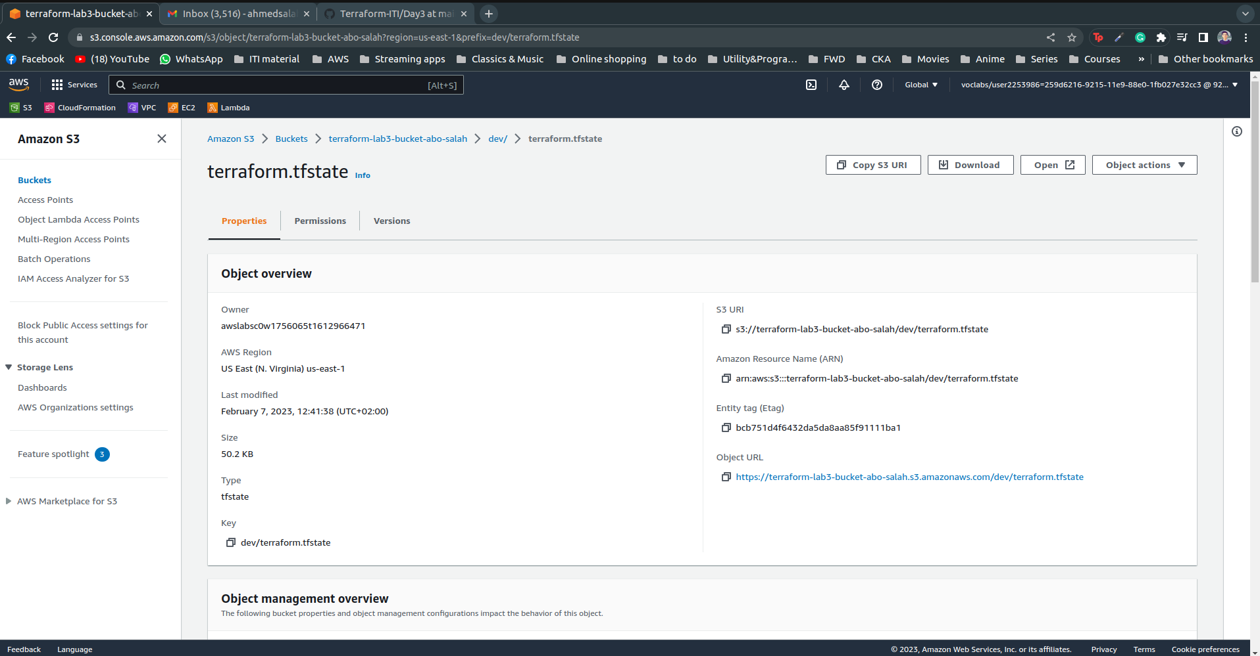

VPC and subnets
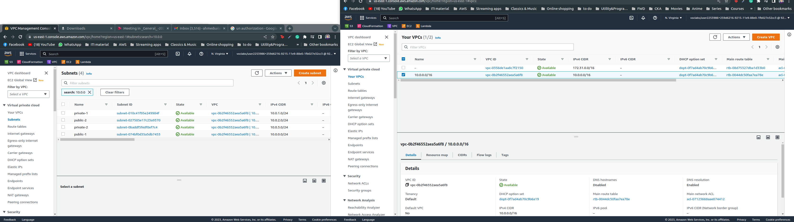

NAT Gateway & Internet Gateway
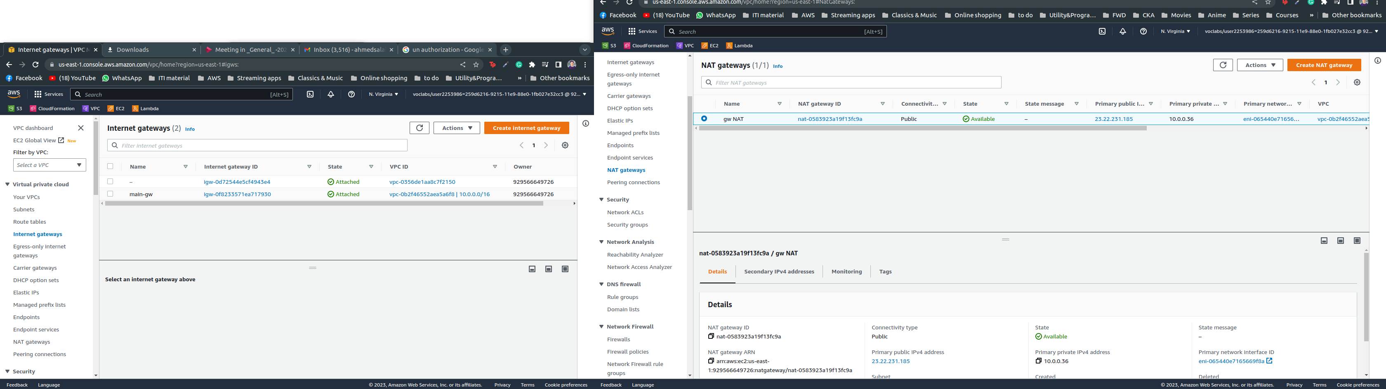
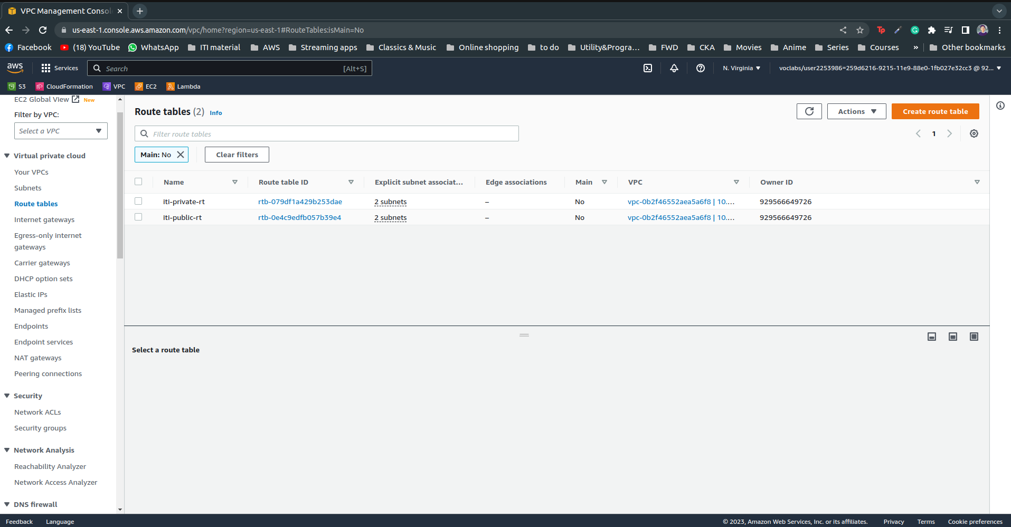
RouteTables

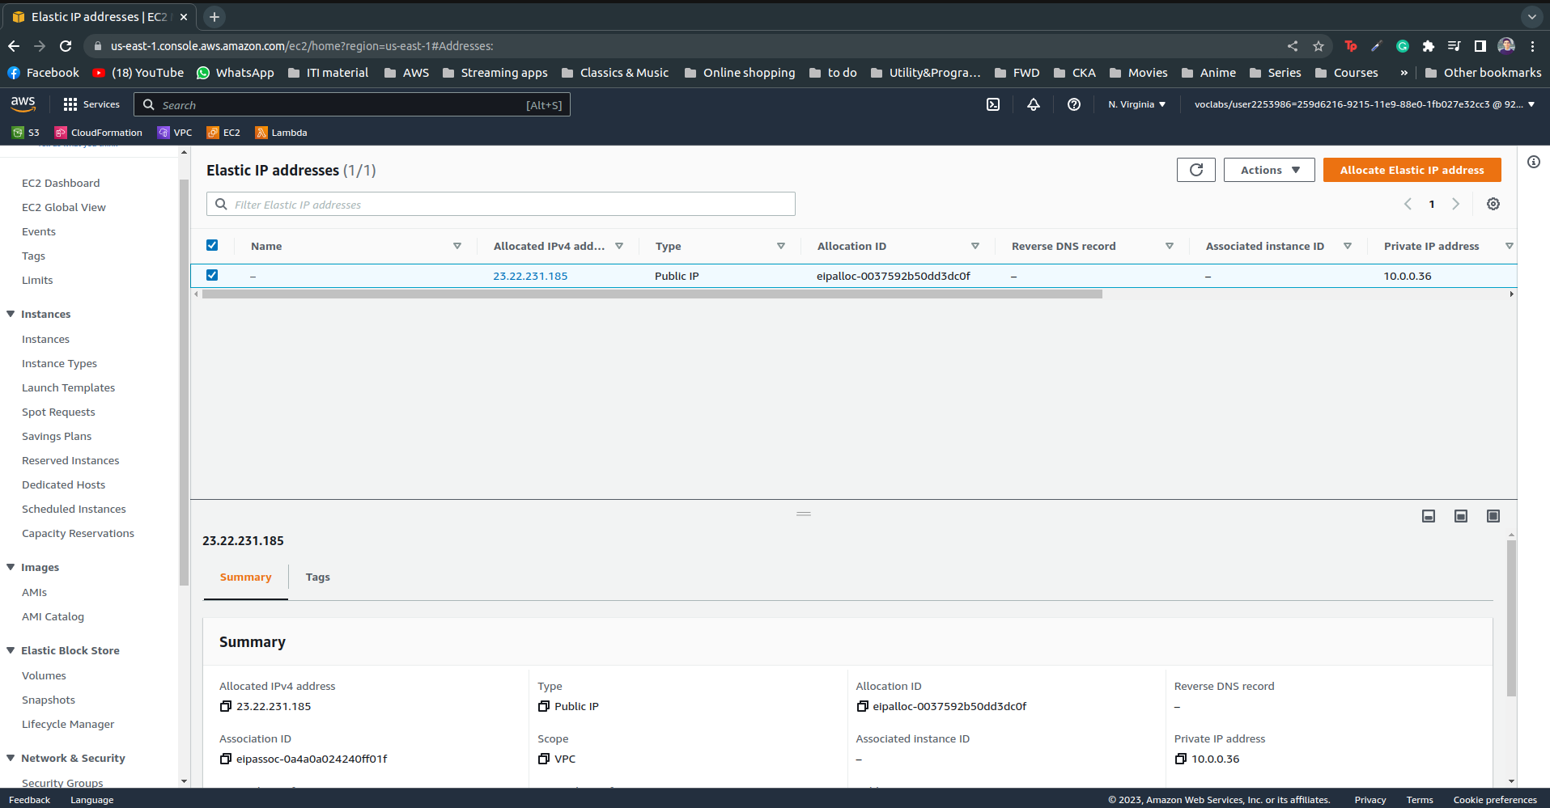
EIP

